How are online dating services changing offline dating?
ROUGH DRAFT

How are Online Dating Services Changing Old Offline Dating?
Online dating has emerged since the beginning of it and has become a very popular told to meet others and establish a relationship through it (Ali and Wibowo, 2011). With individuals using online dating services and becoming members, it has brought a huge amount of growth in revenue to the online dating business. Other online dating sites have joined the online dating business because of the huge amount of profits that have been coming into these online dating sites. “In terms of profits from online dating services, Mitchell (2009) provides evidence of the extensive growth of this kind of business and state that online dating website constitute their most profitable kind of business on the web” (Ali and Wibowo, 2011).
Top Online Paid Content Sites in 2008 by Category ($ in millions)
Digital music $1,732
Video games $1,866
Dating $957

Table 1. Top Online Paid Content Sites in 2008 by Category. Data Source: Online dating: It's bigger than porn (2009).
With the statistics showing that online dating is number three in the 2008 list, this shows the growth of people using online dating services. According to Ali and Wibow (2011) there is an estimate of 800-pluss online dating services provided to the people and as time goes by, the online dating business will continue to grow. But what has driven this type of growth and having online dating services changing offline dating?
Online dating services have been around ever since the web came along. According to (Brainz.org), it is said that online dating was being used even before web sites were even created. With the internet just getting started and slowly growing to what it is today, online dating sites were not provided yet. However, this did not stop individuals from meeting others through the web. Online dating was first used through online chat rooms and blogging sites. People would meet others online and communicate through online chat rooms which played as a host for online dating. According to (Brainz.org), it was the only way of communicating and “dating online” because of technology limitations since the web was freshly new.
In 1994 and 1995, kiss.com and match.com were two of most popular and first online dating sites that were provided on the web for people to use. These two sites were one of the most focused and popular dating sites that were offered to the community and became well respected. Since the growth of these two sites, according to (Braiz.org) by 1996 there were an additional 16 dating sites listed in Yahoo.com. Online dating started becoming one of the popular things to do for people. In “1998, inter dating got a cultural boost with the release of the movie “You’ve Got Mail.” The movie, which reunited “Sleepless in Seattle’s” Tom Hanks and Meg Ryan, focused on two business rivals who hated each other in person but fell in love over the web” (Brainz.org). Ever since the release of the movie, online dating became even more popular and online social networks started coming along such the release of MySpace in 2002. With social networks growing and people meeting their partners through it, people started moving a lot more to online dating service and moving out of offline dating.
In 2007 (Brainz.org) states that Americans spent over $500 million dollars on online dating service, which shows that people are moving to online dating. There are many dating sites that are now offered over the web which makes each of them competitive in the online dating business. However, each site has their own specific rules, requirements, and features that they offer. “What started as a general online dating service conducted through web sites has evolved into a number of categories and classifications. Each category provides either different kinds of services or offer the same service to different groups of people on their religion, ethnic background, sexual orientation, or other categories” (Ali and Wibowo, 2011). The main purpose of online dating is to match two different members with a person that is best compatible to them based on characteristics that they had listed in their member profile. The question now rises on how online dating sites do the right match for their members?
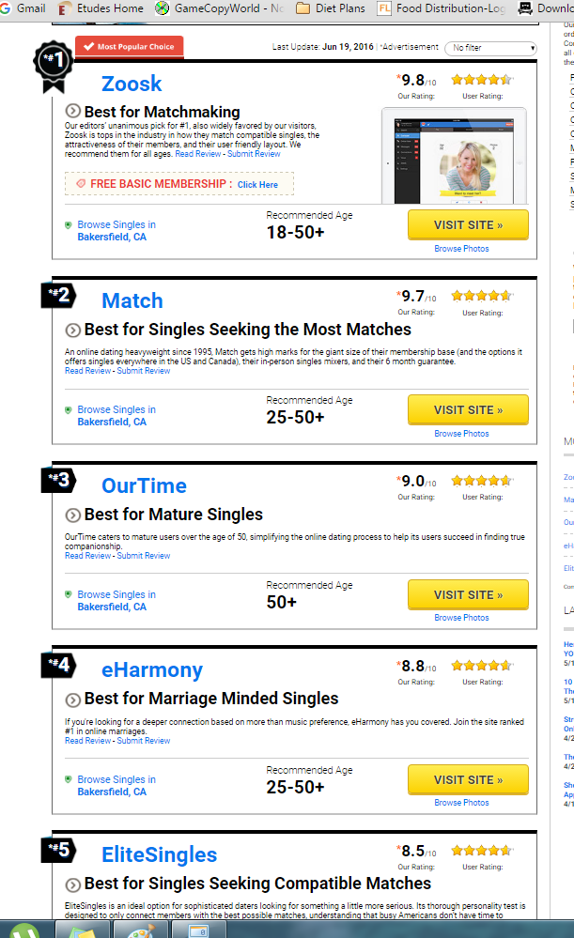
Figure 1. Top 5 Online Dating Sites with Main Features, Membership Base, Overall Rating, and Summary. Source Data: http://www.consumer-rankings.com/dating/ (Last update: June 19, 2016)
To begin with, many different sites have their own rules and features. For example, ChristianMingle.com requires you to be Christian, BlackPeopleMeet.com will ask that the member are African American, and the list can go on and on with all the different dating sites that are now offered. Once you have the specific site that you will like to use, the next step will be to become a member. Majority of the sites will require you to become a member and pay a fee in order to use their services. A membership is required in order to create a personal profile and have a way to introduce yourself to the public. Once the profile has been created, the questionnaire is the next step in order to find a compatible match. The questionnaire can vary depending on the online dating site that you are using. Some online sites such as eHarmony.com ask their members to answer about 200-300 questions in order to find their match. Once the questionnaire is completed by the member, it’s up to the online software to find a compatible match. Online software is used in order to match you with another member. According to John Tierney (2013) eHarmony is one of the sites that uses computerized algorithms in order to help match members with their soul mate. EHarmony is one of the sites that do not let their members find their own match however; they use their software to find the match for them. EHarmony was able to develop this software by asking more 44 million people and gathering the answers to help find matches for their members. According to John Tierney (2013), the more similar that the two members score, the better their chances.
Online dating is very different from offline dating. With online dating still growing, it has changed offline dating. For example, in offline dating, you had to go out to social places or meet others through friends and family members in order to get to know someone and move on from there into a date. From a personal experience, I was a real shy guy as growing up and didn’t not had the confidence to approach someone and ask them out in a date. It was real difficult for me to go out in a date because of those reasons and as growing up I just felt that I was going to be alone for the rest of my life. As I started getting into Jr. College, I went through a major transition. I had gotten into shape and developed the confidence that I now have to ask someone out in a date. However, I started focusing in my career, school, and work which led to no time to go out and have a social life. I am one of the individuals that started adapting to our fast paced lifestyle that we have today. I later on came to find out that there were online dating services and started exploring them in order to meet other people. I started using today modern technology and moving to online dating services. I remember using online dating sites in February because it was around the time that I felt a little lonely after watching everyone having a valentine for Valentine’s Day. “For online-dating agencies, it is a golden opportunity, as people who have spent the holidays ruminating over unsatisfactory or non-existent love lives log on in their thousands, hoping to find romance--ideally before February 14th. "The period between New Year's Day and Valentine's Day is our busiest six weeks of the year,"” ( The Economist, 2011). I later on met my partner through an online dating site and have been happily together for 6 years. In table 2, you are able to see more in detail the comparison between online dating and offline dating. As you can see as time goes by, offline dating will continue to fade away and online dating will replace the way we start dating and meeting others.
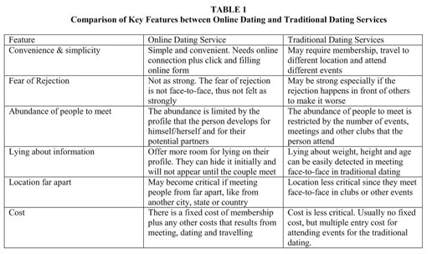
Table 2. Comparison of Key Features between Online Dating and Offline Dating Services. Data Source: Online dating services-chronology and key features comparison with offline dating (2011).
In summary, this paper focuses on online dating services and how online dating services changed offline dating. The paper started by giving an introduction on online dating services and the growth of the online dating business. The paper later focused on the features that it offers and the services that are online for online dating in terms the types of online dating sites like eHarmony.com, Match.com, and many more. I also provide figures and table of the top online dating sites and what each site offers. The paper later shifts to the difference of online dating and offline dating and also gave personal experiences and examples that I have gone through offline dating and online dating. Last, table 2 was provided to show the comparison of key features between online dating and offline dating services. As we can also see, through time technology will continue to evolve and people start moving to was is used now in the modern life, which is a reason why people started moving out of offline dating and moving into online dating services.

References
5 Best Dating Sites | Top Dating Site Reviews | Consumer-Rankings.com. (n.d.). Product Ratings and Reviews | Consumer-Rankings.com. Retrieved June 19, 2016, from http://www.consumer-rankings.com/dating/
Ali, A. I., & Wibowo, K. (2011, June). Online dating services--chronology and key features comparison with offline dating. Competition Forum, 9(2), 481+. Retrieved from http://go.galegroup.com/ps/i.do?id=GALE%7CA286254586&v=2.1&u=nu_main&it=r& p=AONE&sw=w
History of Online Dating. (n.d.). Brainz — Learn something new today.. Retrieved June 19, 2016, from http://brainz.org/history-online-dating/
Jayson, S. (2013, January 23). Online dating has changed everything, author says. USA TODAY: Latest World and US News - USATODAY.com. Retrieved June 19, 2016, from http://www.usatoday.com/story/news/nation/2013/01/23/love-algorithms-online- dating/1856853/
Love at first byte; Online dating. (2011, January 1). The Economist, 398(8714), 52(US). Retrieved fromhttp://go.galegroup.com/ps/i.do?id=GALE%7CA245429037&v=2.1 &u=nu_main&it=r&p=AONE&sw=w
Tierney, J. (2013, February 12). A Match Made in the Code. New York Times, p. D3(L). Retrieved from http://go.galegroup.com/ps/i.do?id=GALE%7CA318392229
&v=2.1&u=nu_main&it=r&p=AONE&sw=w
Top 10 Best Dating Sites - Dating Websites Reviews - Online Dating Sites. (n.d.). Top 10 Best Dating Sites - Dating Websites Reviews - Online Dating Sites. Retrieved June 19, 2016, from http://www.top10bestdatingsites.com/index.php?kw=online%20dating%
20rankings&c=17521

